Creaet ApiGateWay

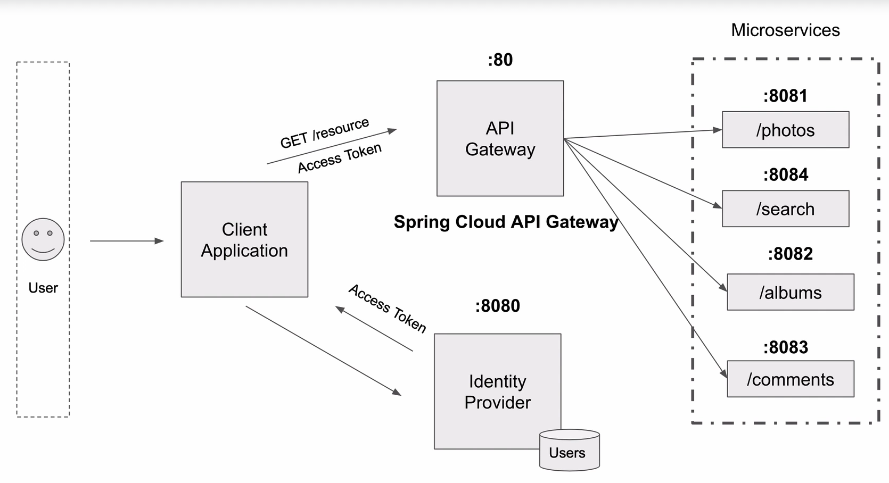

ដើម្បីអាចអោយយើងប្រើប្រាស់ Microservice Resource បានច្រើនយើងត្រូវបង្កើត ApiGateWay មួយដែលអាចអោយវាទៅយក MS របស់យើង

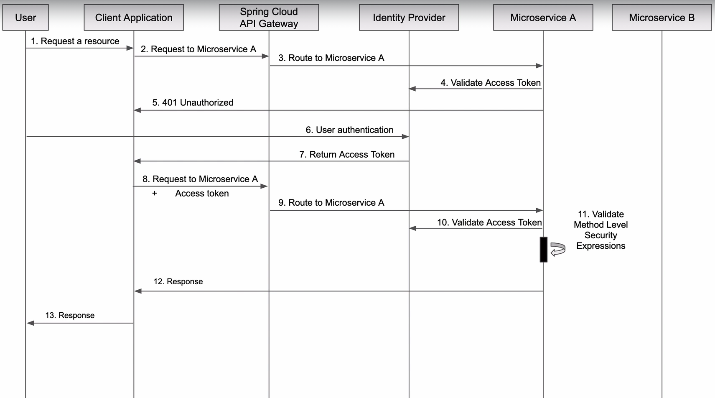

ដើម្បីអោយ client access to the resource server បានវាត្រូវធ្វើការ Request to the ApiGateWay first then the ApiGateWay will access to the Resource Server. In first time it will request token from the Client. If it not have the client will reques tot Auther Server to get the Token.

- Create ApiGateWay Server
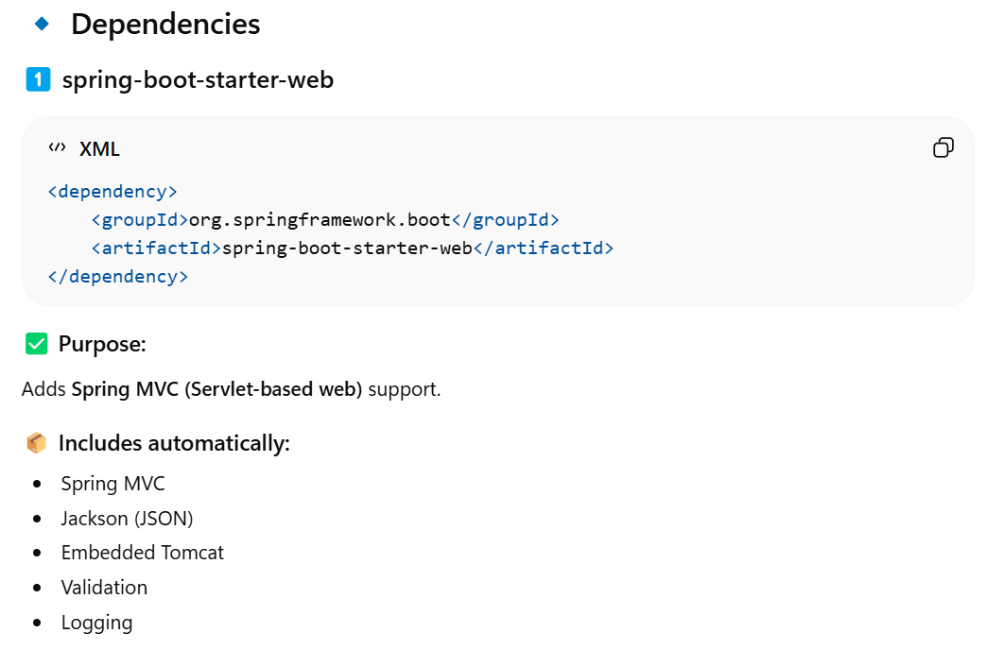

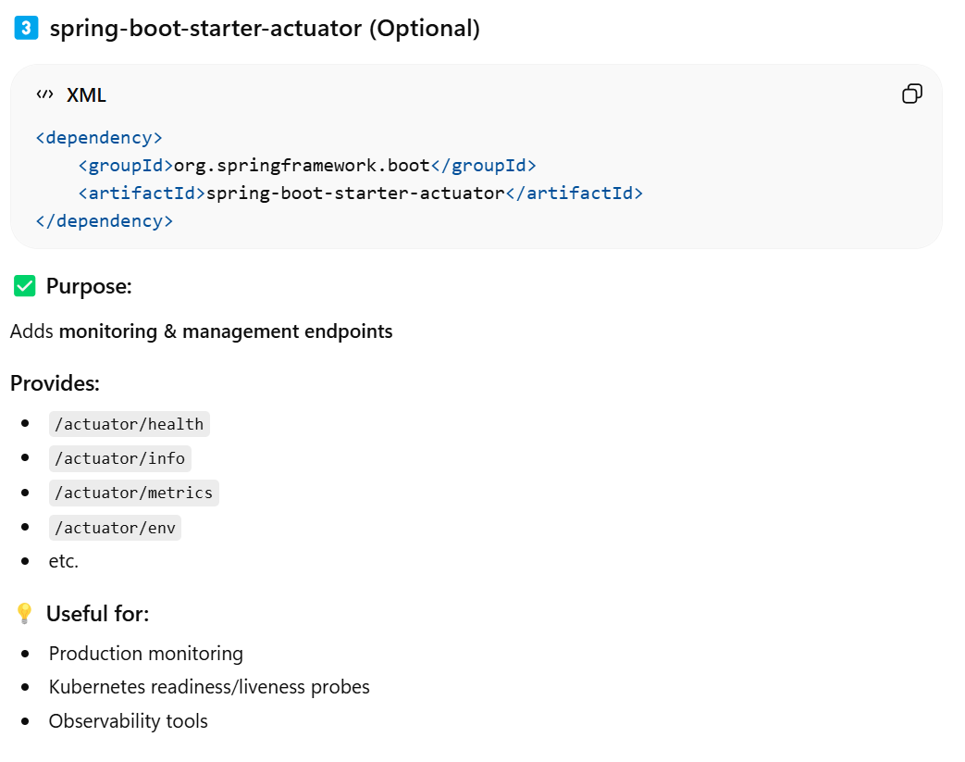

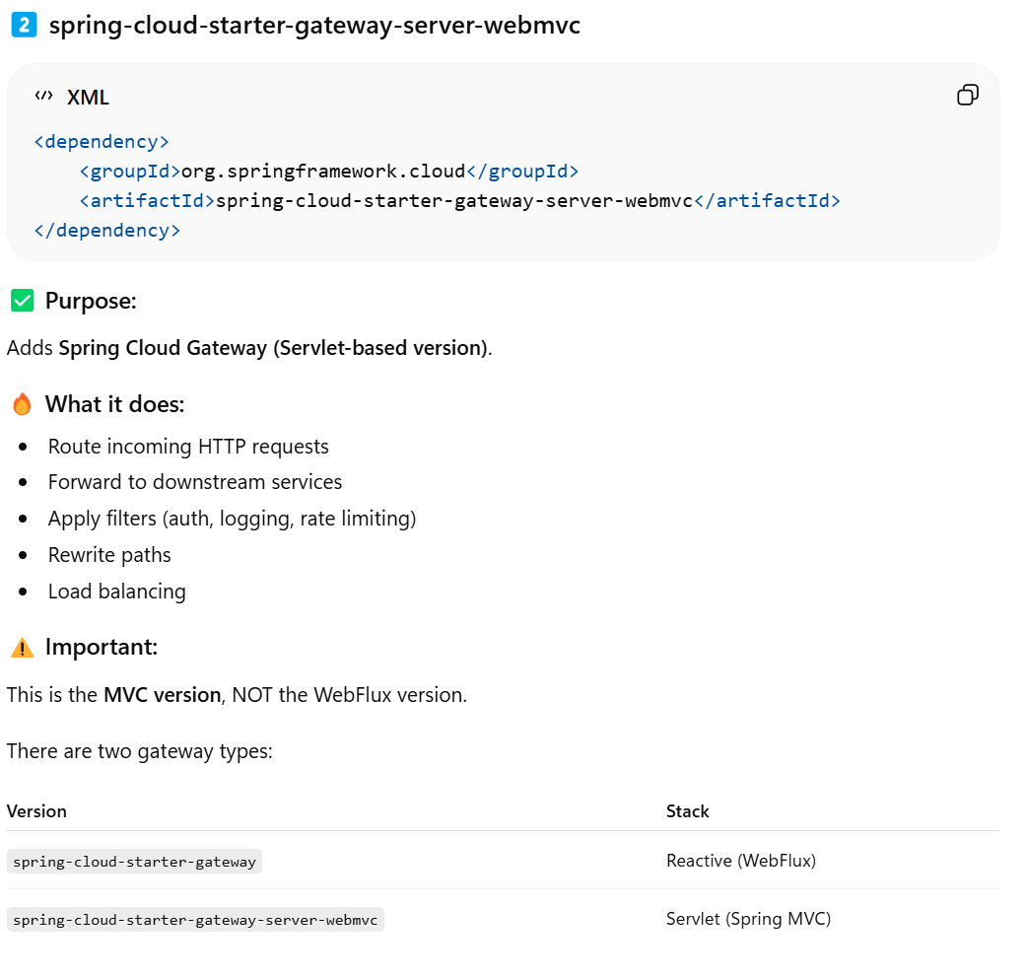

កន្លែងដែល Error យើងត្រូវអាចប្រើ ពីរ Webflux and MVC ដោយសារតែ Project នេះគេប្រើ Spring MVC ចឹងយើងត្រូវប្រើ MVC ដែល។ សម្រាប់ New Version Spring boot for the ApiGateway it will use spring cloud with Webflux.
- Spring Cloud MVC
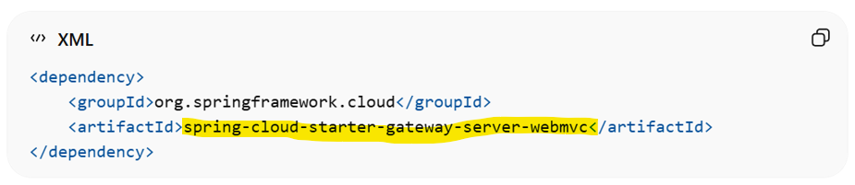

- Create configuration class in ApiGateWay
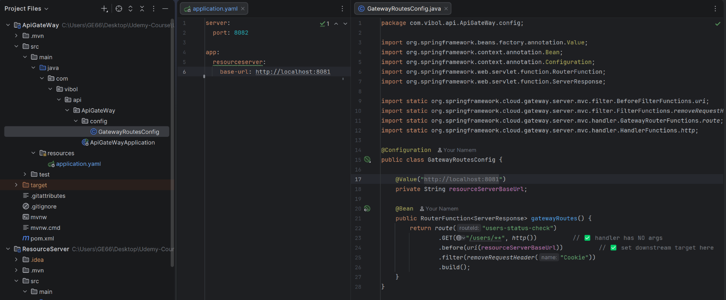

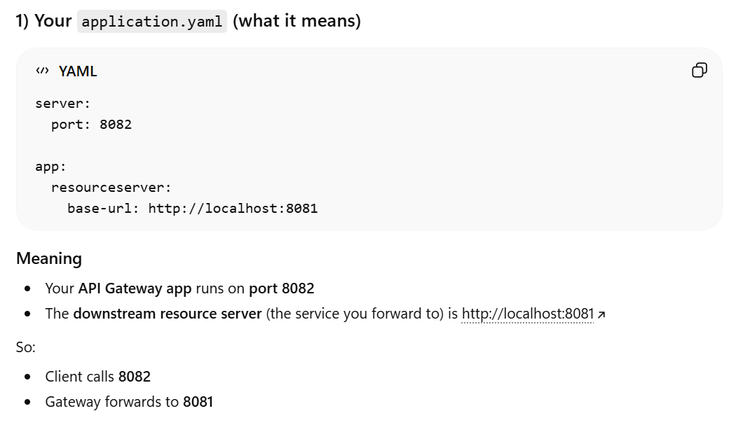

- ពេល Client Called to the port 8082/users/status/check it will forward to port 8081

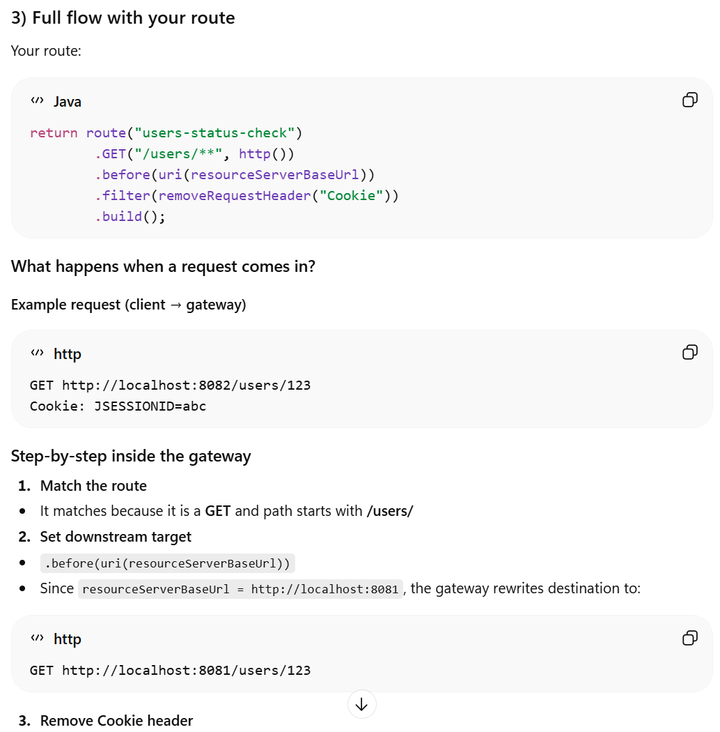

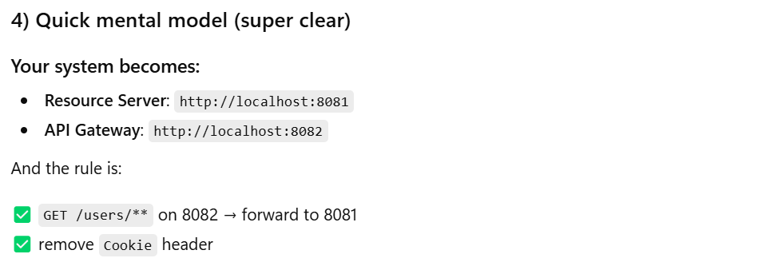

- Testing in Postman
- Client request token from Auth Server: port 8080
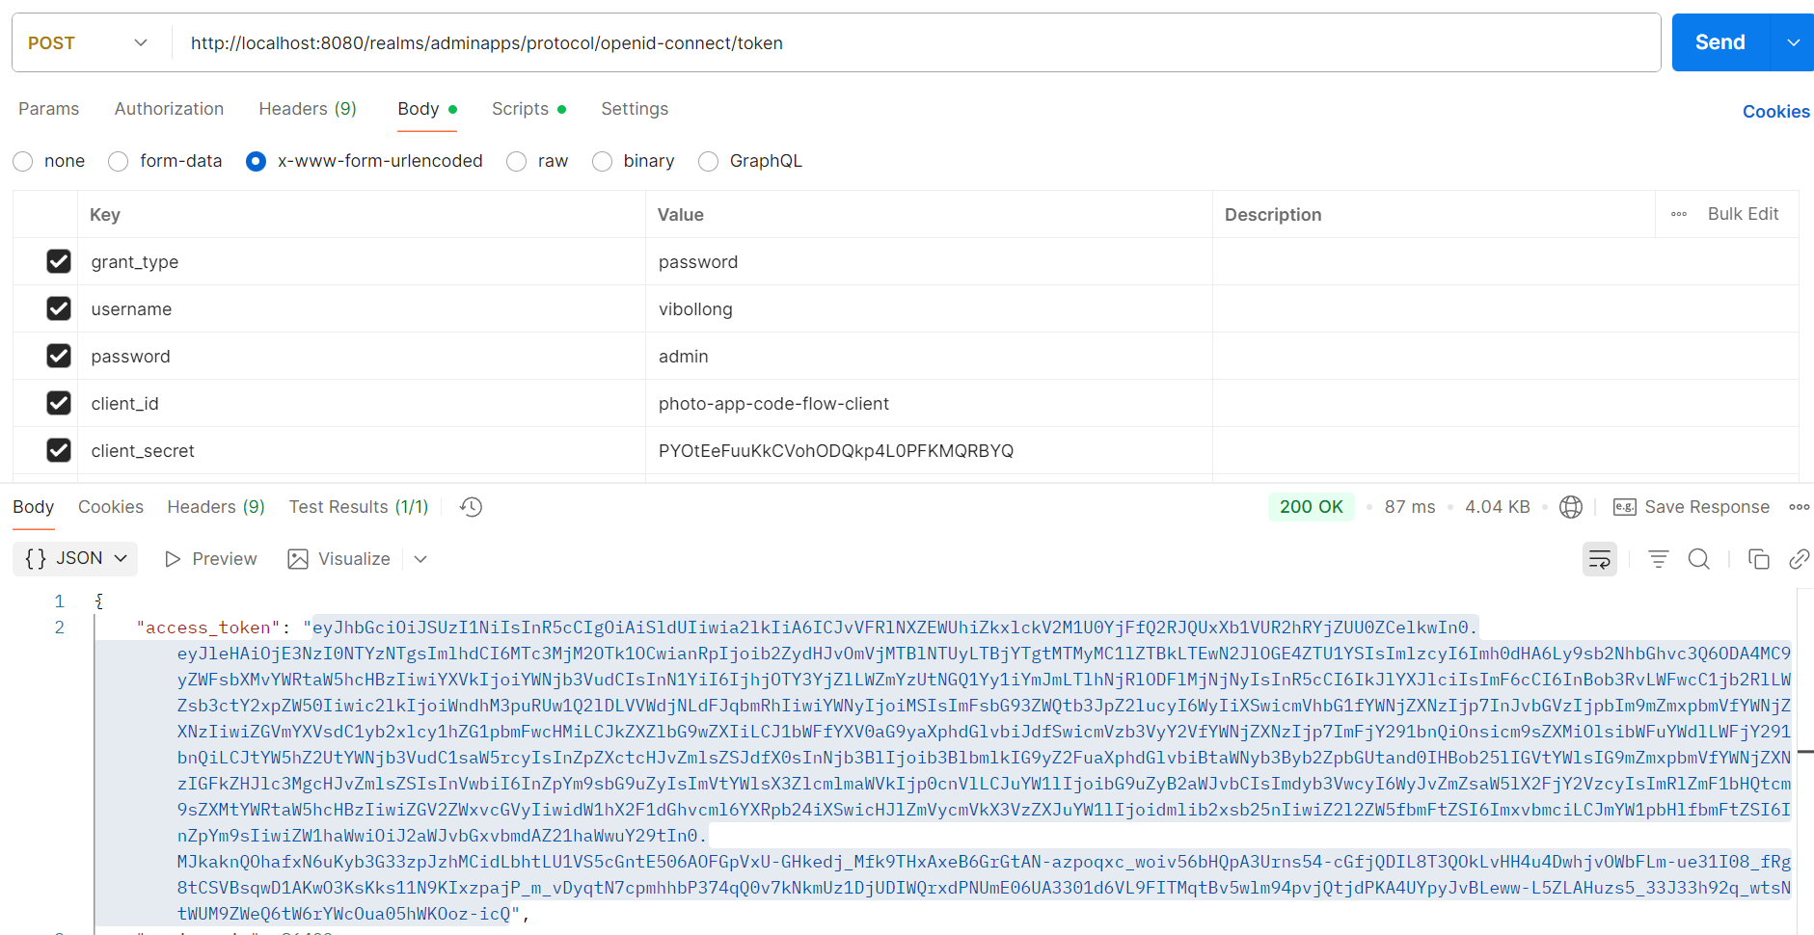

- GetRequest directly from Client to the Resource Server port 8081
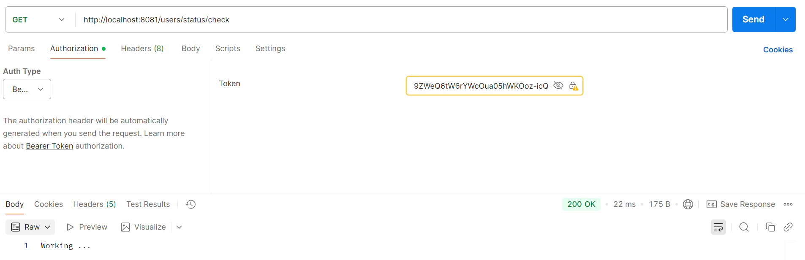

GET: http://localhost:8081/users/status/check

- Request To ApiGateWay via port 8082

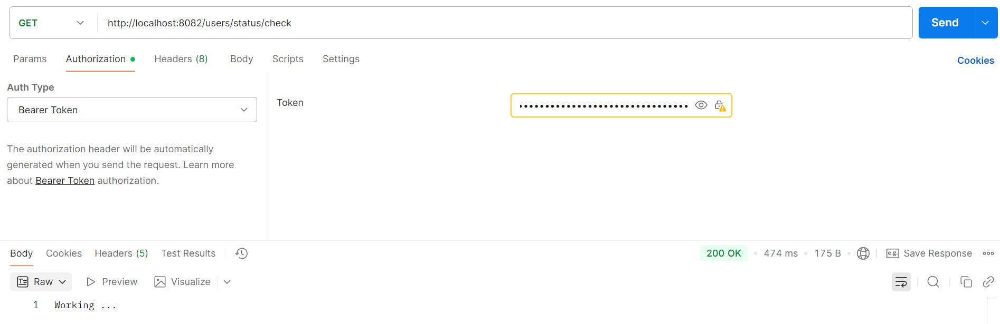

GET: http://localhost:8082/users/status/check

